Joyful Discoveries – Year 1 Implementation Plan
Unit 1   | Unit 2  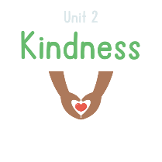 | Unit 3   | Unit 4   | Unit 5a   | Unit 6   | Unit 7a   | Unit 8  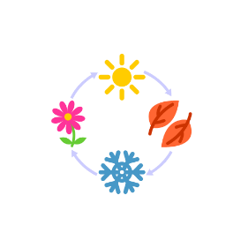 | Unit 9  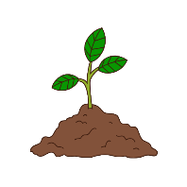
Start: | Start: | Start: | Start: | Start: | Start: | Start: | Start: | Start:
End: | End: | End: | End: | End: | End: | End: | End: | End:
#Days: | #Days: | #Days: | #Days: | #Days: | #Days: | #Days: | #Days: | #Days:
#Books: | #Books: | #Books: | #Books: | #Books: | #Books: | #Books: | #Books: | #Books:
Notes- | Notes- | Notes- | Notes- | Notes- | Notes- | Notes- | Notes- | Notes-

